United Airlines Time Recovery Analysis in 2013

Team Members

Dan Nguyen, Jennifer Poling, Paul Skentzos

Introduction
Airlines care deeply about operational efficiency, which affects cost, and customer satisfaction, which affects repeat business. Both depend heavily on on-time performance. While departure delays naturally receive the most attention, an equally important part of the story is how often flights recover time while airborne. A late departure does not always mean a late arrival, and understanding the conditions under which aircraft make up lost time can help improve scheduling, performance forecasting, and operational planning.
In this project, we analyze United Airlines flights departing from the three major New York City airports in 2013 to understand how much time flights tend to make up while en route to their destination airports. The dataset contains tens of thousands of flights, providing a strong foundation for identifying consistent patterns in time recovery.
Our analysis focuses on two measures:
- Net gain, which is the number of minutes a flight makes up between departure and arrival.
- Gain per hour, which adjusts for flight duration so shorter and longer flights can be fairly compared.
Using these measures, we examine how time recovery differs across several factors, including departure punctuality, destination airports, and flight length categories. This project builds on earlier work that focused on departure delays by shifting attention to what happens once an aircraft is in the air.
With further development, this exploratory analysis can help identify when and where airlines can realistically expect to regain lost time. These insights support schedule design, operational decision making, and customer-facing performance metrics.

Data Methodology
To conduct this analysis, we used a dataset from the nycflights13 package (this data is part of the R Studio system and is easily loaded as such: library(nycflights13). This data set contains all 336,776 flights from 2013.
Our preparation involved several steps to make the data easy to analyze and understand:
- Focus on United: We filtered the main dataset to look at only the 57,979 flights operated by United Airlines.
- Define "Late": We created two simple categories to better understand delays. We marked a flight as "late" if it departed more than 0 minutes after its scheduled time, and "very late" if it departed more than 30 minutes after its scheduled time.
- Create Gain Column: We subtracted arrival delay from departure delay to create a column that shows how much quicker the flight ended up being than planned.
- Destination Airports: To find the five most common destination airports for United Airlines flights from New York City, we filtered the United Airlines dataset to look at only the flights leaving from JFK, Newark, and LaGuardia.
- Create Gain Per Hour Column: We created a gain per hour column by dividing the total gain by the duration in hours of each flight.
- Define “Short”: We created a short column that was true if the flight was 200 minutes or less and false if the flight was over 200 minutes.

Results
1.1. Does the average gain differ for flights that departed late versus those that did not?
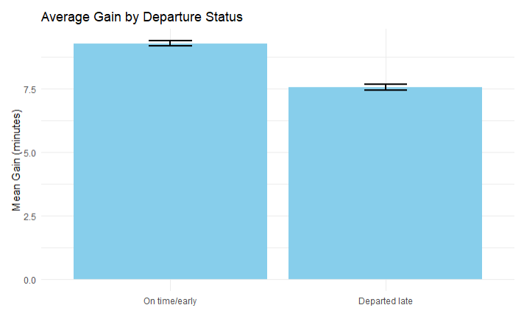
Figure 1. Average gain between on time departures and late departures.

Degree of Freedom | T-Statistic | P-Value | 95% Confidence Interval
52833 | 10.749 | 2.2e-16 | (1.411, 2.04)
Table 1. Welch two sample t-test results between on time departures and late departures.

Figure 1 compares the average gain for flights that departed on time with those that departed late. Flights leaving early or on time gained an average of 9.3 minutes, while late-departing flights gained 7.5 minutes on average. To assess whether this difference is statistically meaningful, a two-sample t-test with unequal variances was conducted (Table 1). The test produced a p-value of 2.2e-16 and a 95% confidence interval for the difference of (1.411, 2.04). Although the difference is statistically significant, its magnitude is small.

1. 2. Does the average gain differ for flights that departed very late versus those that did not?
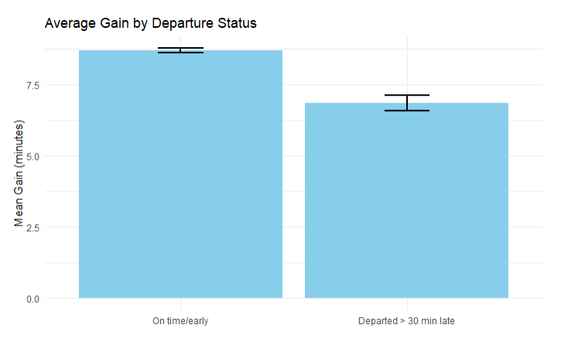
Figure 2. Average gain between on-time/slightly-late departures and very late departures.

Degree of Freedom | T-Statistic | P-Value | 95% Confidence Interval
8838.6 | 6.2953 | 3.215e-10 | (1.268, 2.415)
Table 2. Welch two sample t-test results between on-time/slightly-late departures and very late departures.

Figure 2 displays the average gain for flights that departed early, on-time, or slightly late compared with those that departed very late (by more than 30 minutes). Flights that departed very late gained 6.8 minutes on average whereas those did not gained 8.7 minutes. A two-sample t-test assuming unequal variances was used to evaluate the significance of this difference. The test yielded a p-value of 3.215e-10 and a 95% confidence interval of (1.268, 2.415). These results indicate that, while the difference in gain between the two groups is statistically significant, it is practically quite small.

2. Most common destination airports for United Airlines flights from New York City

Destination | Number of Flights | Mean Gain (minutes) | SD Gain
IAH | 6814 | 6.861 | 18.44
ORD | 6744 | 7.777 | 19.15
SFO | 6728 | 8.695 | 22.40
LAX | 5770 | 7.825 | 21.91
DEN | 3737 | 7.302 | 20.04
Table 3. Summary statistics of 5 most common destination airports for United Airlines flights from New York City.

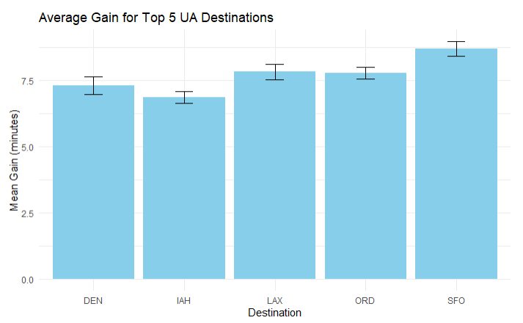
Figure 3. Average Gain for 5 most common destination airports for United Airlines flights from New York City.

3. 1. Does the average gain per hour differ for flights that departed late versus those that did not?
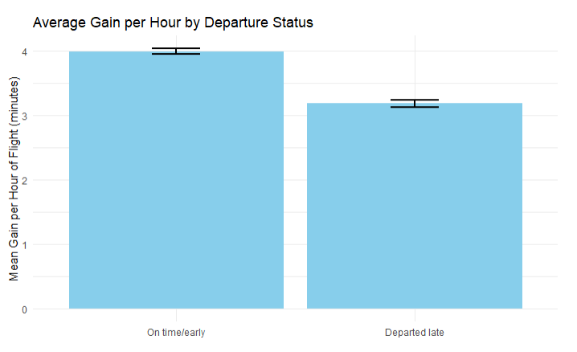
Figure 4. Average gain per hour between on time departures and late departures.

Degree of Freedom | T-Statistic | P-Value | 95% Confidence Interval
53125 | 11.285 | 2.2e-16 | (0.666, 0.946)
Table 4. Welch two sample t-test results between on time departures and late departures.

Bootstrap (N=10000) T confidence interval: (0.664, 0.948)

Figure 4 shows the average gain per hour for flights that departed late and those that did not. On average, flights that departed on time gained 3.99 minutes per hour whereas late departures gained 3.184 minutes. Due to concern regarding the normality of the gain per hour variable, both regular and bootstrap t tests were conducted. However, the resulting 95% confidence intervals of the difference in means agree (Table 4) with both suggesting that there is a statistically significant yet negligible difference in gain per hour between on-time and late departures.

3.2. Does the average gain per hour differ for flights that departed very late versus those that did not?
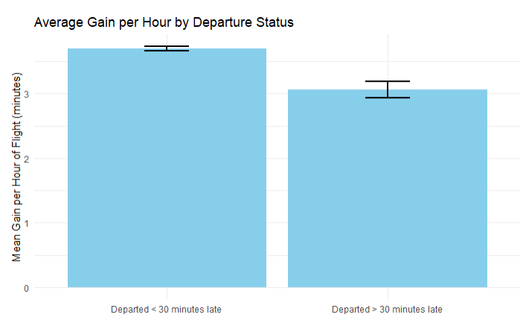
Figure 5. Average gain per hour between on-time/slightly-late departures and very late departures.

Degree of Freedom | T-Statistic | P-Value | 95% Confidence Interval
8835.1 | 4.8323 | 1.372e-06 | (0.3745, 0.8858)
Table 5. Welch two sample t-test results between on-time/slightly-late departures and very late departures.

Figure 5 compares average gain for flights departing on time versus those departing late. Early, on-time, or slightly late departures showed an average gain of 3.7 minutes per hour, while late departures averaged 3.06 minutes. A two-sample t-test with unequal variances was used to test the difference, producing a p-value of 1.372e-06 and a 95% confidence interval of (0.3745, 0.8858). These results confirm a statistically significant difference in gain between the groups, though the size of the difference is minimal.

4. Does the average gain per hour differ for longer flights versus shorter flights?
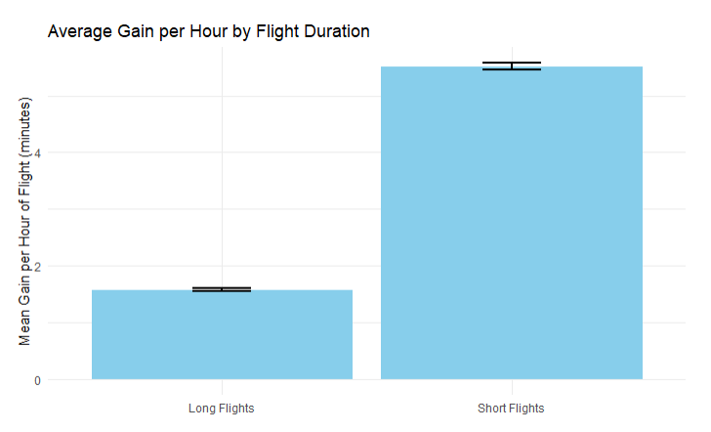
Figure 6. Average gain per hour between long and short flights.

Degree of Freedom | T-Statistic | P-Value | 95% Confidence Interval
40524 | -58.677 | 2.2e-16 | (-4.07, -3.8)
Table 6. Welch two sample t-test results between long and short flights.

On average, long flights (> 200 minutes) tend to have a lower gain of 1.576 minutes per hour whereas shorter flights have a gain of 5.515 minutes per hour (Figure 6). A Two sample t-test confirms the significance of this difference with a P-Value of 2.2e-16.

Discussion
Across all analyses, several themes emerged.
First, flights generally recover time en route, but late departures do not recover more time than on-time flights.
In our data, on-time flights made up more time on average than late-departing flights, and very late flights recovered even less. This means that being late at the gate does not create an advantage in recovering time during flight. In other words, a late start does not translate into an aggressive attempt to “catch up” in the air; there are factors that must be taken into account in order to manage fuel, etc. While time recovery might help soften the impact of delays from the passenger perspective, the operational benefit is modest, typically just a few minutes, and would need to be weighed against fuel, routing, and air-traffic constraints.
Second, recovery varies by route.
Our analysis of the five most common United Airlines destinations showed that some routes consistently allow more time recovery (e.g., SFO) while others allow less (e.g., IAH). These differences likely reflect factors beyond the scope of our dataset, including route length, airspace complexity, typical levels of congestion, and landing flow procedures. More detailed route-specific analysis would be needed to explain these patterns fully.
Third, shorter flights recover much more time per hour than longer flights.
This was the clearest and most practically meaningful finding. After adjusting for flight duration, short flights recovered roughly 5.5 minutes per hour, compared to 1.6 minutes per hour for long flights. Short flights spend proportionally more time in climb, descent, and approach, phases where speeds and sequencing can be adjusted, while long flights spend hours in steady cruise where adjustments have minimal effect. This result aligns with real-world operational behavior, although confirming causation would require additional aviation-specific data.
Taken together, these findings suggest that United Airlines can realistically expect some amount of time recovery on many flights, but the magnitude is generally small. Late departures do not consistently recover more time, and very late departures perform worse. The strongest and most actionable insight is that shorter flights are far more efficient at gaining time relative to their duration. These patterns can help refine scheduling decisions, improve arrival-time forecasting, and set better customer expectations.
Future work should incorporate additional variables such as weather along the full route, air-traffic congestion, runway configurations, and crew or gate constraints. Integrating these factors with time-recovery metrics may offer a more complete view of when and why flights gain or lose time during airborne operations and could help airlines design more resilient schedules.

